Weston Jump

11-15-16

HIS 470-01

Dr. Andrew Denson

**Ronnie Carr**

Ronnie Carr is originally from South Carolina and was born in the town of Orangeburg in 1961 and moved to New York where he grew up as a child and eventually returned to Orangeburg to graduate high school. He played Basketball for Western Carolina University during his graduated 1979 ((1979-1980)) and his life would change forever when he played against ((Middle Tennessee State)). Ronnie Carr played as shooting guard aka “2nd guard” and received the ball during the ((1st half)) and he made the first three-point shot in college basketball history securing his place in the National Basketball Hall of Fame. Ironically, Ronnie Carr wore #22 and the 3-point arc in that first year was 22 feet, instead of the now 19-feet, nine-inches. Carr chose #22 as a freshman and the 3-pont shot did not debut until Carr’s sophomore season.

No other athlete had achieved such a feat until that day. Ronnie was chosen to go to UNC Chapel Hill Basketball Camp for two weeks but the first week he was invited to a cookout with Michael Jordan and other famous athletes. Ronnie was traveling on highway 15-501 and was lost and there was very rainy weather when he looked over his steering wheel a police car was supposedly chasing another vehicle tried to slide around his car but driver’s side over an excess of 100 mph Ronnie suffered a concussion, broken collar bones on both sides, two broken arms, a severely fractured left wrist, two broken legs, a severely fractured and lacerated left ankle. The impact was so severe that left mitral valve away from his heart.

Ronnie had to have open heart surgery and be hospitalized for a good while for various surgeries. Ronnie was able to find a new purpose outside of basketball when he found the help the youth of the East Coast when he established the Ronnie Carr Foundation to help others through his experience. To this day Ronnie continues to work for his foundation and help the youth of east coast by speaking at public venues.

Ronnie Carr’s philosophy for helping these people is to speak positively and to emphasize that even though something can be taken from you that you can learn from the experience and rise above it. This has been the key to improving people’s quality of life and helping them chase their dreams.

Exhibit Elements: Photos from Career and Bio.

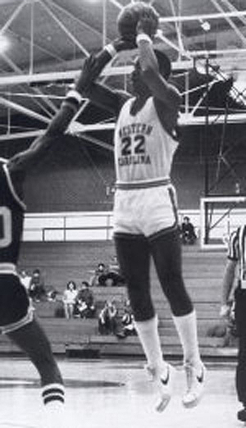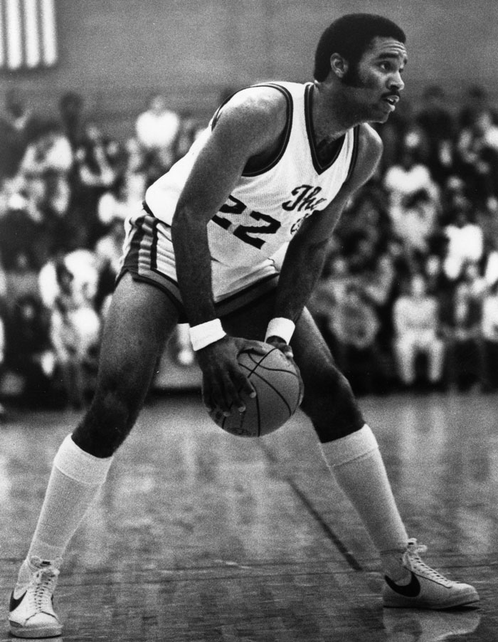

**Works Cited**

RONNIE CARR - CBS Sports Network." N.p., n.d. Web. 15 Nov. 2016.

Bambach, Mike. "GREATEST MOMENTS | WCU’s Ronnie Carr Made College Basketball’s First 3-pointer." American Sports Network. N.p., n.d. Web. 15 Nov. 2016

(Ronnie Carr, personal communication, November 15, 2016)